Robert's Rules of Order

According to Robert's Rules of Order, parliamentary procedure is based on the consideration of the rights of the majority, the rights of the minority (especially a large minority greater than one-third), the rights of individual members, the rights of absentee members, and the rights of all of these groups taken together.

If the bylaws* of an organization specify RONR as the adopted parliamentary authority, then that book should be used. The Fourth edition can serve as a useful reference tool but, by all means, get a copy of the current edition of RONR; it contains much information and details not available in the Fourth Edition.

Introduction to Robert's Rules of Order http://www.robertsrules.org/rulesintro.htm

- What is Parliamentary Procedure?
- Why is Parliamentary Procedure Important?
- Example of the Order of Business
- Motions
- Types of Motions
- How are Motions Presented?
- Voting on a Motion

What Is Parliamentary Procedure?
It is a set of rules for conduct at meetings that allows everyone to be heard and to make decisions without confusion.

Why is Parliamentary Procedure Important?
Because it's a time tested method of conducting business at meetings and public gatherings. It can be adapted to fit the needs of any organization. Today, Robert's Rules of Order newly revised is the basic handbook of operation for most clubs, organizations and other groups. So it's important that everyone know these basic rules!

Organizations using parliamentary procedure usually follow a fixed order of business. Below is a typical example:

- Call to order.
- Roll call of members present.
- Reading of minutes of last meeting.
- Officer’s reports.
- Committee reports.
- Special orders: Important business previously designated for consideration at this meeting.
- Unfinished business.
- New business.
- Announcements.
- Adjournment.

The method used by members to express themselves is in the form of moving motions. A motion is a proposal that the entire membership take action or a stand on an issue. Individual members can:

- Call to order.
- Second motions.
- Debate motions.
- Vote on motions.

There are four Basic Types of Motions:
- Main Motions: The purpose of a main motion is to introduce items to the membership for their consideration. They cannot be made when any other motion is on the floor, and yield to privileged, subsidiary, and incidental motions.
- Subsidiary Motions: Their purpose is to change or affect how a main motion is handled, and is voted on before a main motion.
- Privileged Motions: Their purpose is to bring up items that are urgent about special or important matters unrelated to pending business.
- Incidental Motions: Their purpose is to provide a means of questioning procedure concerning other motions and must be considered before the other motion.

How are Motions Presented?
- Obtaining the floor
  - Wait until the last speaker has finished.
  - Rise and address the Chairman by saying, "Mr. Chairman, or Mr. President."
  - Wait until the Chairman recognizes you.
- Make Your Motion
  - Speak in a clear and concise manner.
  - Always state a motion affirmatively. Say, "I move that we ..." rather than, "I move that we do not ...".
  - Avoid personalities and stay on your subject.
- Wait for Someone to Second Your Motion
- Another member will second your motion or the Chairman will call for a second.
- If there is no second to your motion it is lost.
- The Chairman States Your Motion
  - The Chairman will say, "it has been moved and seconded that we ..." Thus placing your motion before the membership for consideration and action.
  - The membership then either debates your motion, or may move directly to a vote.
  - Once your motion is presented to the membership by the chairman it becomes "assembly property", and cannot be changed by you without the consent of the members.
- Expanding on Your Motion
  - The time for you to speak in favor of your motion is at this point in time, rather than at the time you present it.
  - The mover is always allowed to speak first.
  - All comments and debate must be directed to the chairman.
  - Keep to the time limit for speaking that has been established.
  - The mover may speak again only after other speakers are finished, unless called upon by the Chairman.
- Putting the Question to the Membership
  - The Chairman asks, "Are you ready to vote on the question?"
  - If there is no more discussion, a vote is taken.
  - On a motion to move the previous question may be adapted.

Voting on a Motion:
The method of vote on any motion depends on the situation and the by-laws of policy of your organization. There are five methods used to vote by most organizations, they are:
- By Voice -- The Chairman asks those in favor to say, "aye", those opposed to say "no". Any member may move for an exact count.
- By Roll Call -- Each member answers "yes" or "no" as his name is called. This method is used when a record of each person's vote is required.
- By General Consent -- When a motion is not likely to be opposed, the Chairman says, "if there is no objection ..." The membership shows agreement by their silence, however if one member says, "I object," the item must be put to a vote.
- By Division -- This is a slight verification of a voice vote. It does not require a count unless the chairman so desires. Members raise their hands or stand.
- By Ballot -- Members write their vote on a slip of paper, this method is used when secrecy is desired.

There are two other motions that are commonly used that relate to voting.
- Motion to Table -- This motion is often used in the attempt to "kill" a motion. The option is always present, however, to "take from the table," for reconsideration by the membership.
- Motion to Postpone Indefinitely -- This is often used as a means of parliamentary strategy and allows opponents of motion to test their strength without an actual vote being taken. Also, debate is once again open on the main motion.

Parliamentary Procedure is the best way to get things done at your meetings. But, it will only work if you use it properly.
- Allow motions that are in order.
- Have members obtain the floor properly.
- Speak clearly and concisely.
- Obey the rules of debate.

Most importantly, BE COURTEOUS.

Robert's Rules of Order - Summary Version - For Fair and Orderly Meetings & Conventions
Robert’s Rules provides common rules and procedures for deliberation and debate in order to place the whole membership on the same footing and speaking the same language. The conduct of ALL business is controlled by the general will of the whole membership - the right of the deliberate majority to decide. Complementary is the right of at least a strong minority to require the majority to be deliberate - to act according to its considered judgment AFTER a full and fair "working through" of the issues involved. Robert's Rules provides for constructive and democratic meetings, to help, not hinder, the business of the assembly. Under no circumstances should "undue strictness" be allowed to intimidate members or limit full participation. The fundamental right of deliberative assemblies requires all questions to be thoroughly discussed before taking action! The assembly rules - they have the final say on everything! Silence means consent! © 1997 Beverly Kennedy http://www.robertsrules.org/indexprint.html
- Obtain the floor (the right to speak) by being the first to stand when the person speaking has finished; state Mr./Madam Chairman. Raising your hand means nothing, and standing while another has the floor is out of order! You must be recognized by the Chair before speaking.
- Debate can not begin until the Chair has stated the motion or resolution and asked "are you ready for the question?" If no one rises, the chair calls for the vote!
- Before the motion is stated by the Chair (the question) members may suggest modification of the motion; the mover can modify as he pleases, or even withdraw the motion without consent of the seconder. If mover modifies, the seconder can withdraw the second.
- The "immediately pending question" is the last question stated by the Chair. Motion/Resolution - Amendment - Motion to Postpone
- The member moving the "immediately pending question" is entitled to preference to the floor.
- No member can speak twice to the same issue until everyone else wishing to speak has spoken to it once.
- All remarks must be directed to the Chair. Remarks must be courteous in language and deportment - avoid all personalities, never allude to others by name or to motives.
- The agenda and all committee reports are merely recommendations. When presented to the assembly and the question is stated, debate begins and changes may occur.

The Rules
- Point of Privilege: Pertains to noise, personal comfort, etc. - may interrupt only if necessary!
- Parliamentary Inquiry: Inquire as to the correct motion - to accomplish a desired result, or raise a point of order.
- Point of Information: Generally applies to information desired from the speaker: "I should like to ask the (speaker) a question."
- Orders of the Day (Agenda): A call to adhere to the agenda (a deviation from the agenda requires Suspending the Rules).
- Point of Order: Infraction of the rules, or improper decorum in speaking. Must be raised immediately after the error is made.
- Main Motion: Brings new business (the next item on the agenda) before the assembly.
- Divide the Question: Divides a motion into two or more separate motions (must be able to stand on their own).
- Consider by Paragraph: Adoption of paper is held until all paragraphs are debated and amended and entire paper is satisfactory; after all paragraphs are considered, the entire paper is then open to amendment, and paragraphs may be further amended. Any Preamble can not be considered until debate on the body of the paper has ceased.
- Amend: Inserting or striking out words or paragraphs, or substituting whole paragraphs or resolutions.
- Withdraw/Modify Motion: Applies only after question is stated; mover can accept an amendment without obtaining the floor.
- Commit /Refer/Recommit to Committee: State the committee to receive the question or resolution; if no committee exists include size of committee desired and method of selecting the members (election or appointment).
- Extend Debate: Applies only to the immediately pending question; extends until a certain time or for a certain period of time.
- Limit Debate: Closing debate at a certain time, or limiting to a certain period of time.
- Postpone to a Certain Time: State the time the motion or agenda item will be resumed
- Object to Consideration: Objection must be stated before discussion or another motion is stated
- Lay on the Table: Temporarily suspends further consideration/action on pending question; may be made after motion to close debate has carried or is pending
- Take from the Table: Resumes consideration of item previously "laid on the table" - state the motion to take from the table
- Reconsider: Can be made only by one on the prevailing side who has changed position or view
- Postpone Indefinitely: Kills the question/resolution for this session - exception: the motion to reconsider can be made this session
- Previous Question: Closes debate if successful - may be moved to "Close Debate" if preferred
- Informal Consideration: Move that the assembly go into "Committee of the Whole" - informal debate as if in committee; this committee may limit number or length of speeches or close debate by other means by a 2/3 vote. All votes, however, are formal.
- Appeal Decision of the Chair: Appeal for the assembly to decide - must be made before other business is resumed; NOT debatable if relates to decorum, violation of rules or order of business
- Suspend the Rules: Allows a violation of the assembly's own rules (except Constitution); the object of the suspension must be specified

Robert's Rules of Order - Some Basics
Edited by Carter McNamara, MBA, PhD. Adapted from the Field Guide to Developing and Operating Your Nonprofit Board of Directors.
The following was condensed from the Robert's Rules of Order and includes typical rules to manage a board meeting. Readers wanting the last official version should see Robert's Rule of Order Newly Revised, published by Scott, Foresman (known as NONR). This is the 9th Edition of Robert's book.
All motions must be seconded and adopted by a majority vote unless otherwise noted.
All motions may be debated unless otherwise noted.

About Motions
About Motions | Purpose of Motion | To Enact Motion
Main Motion | to take action on behalf of the body | debatable; requires majority vote
Adjourn | end the meeting | not debatable; immediately voted upon and requires majority vote
Call for Orders of the Day | asks to stick to the agenda | not debatable; requires 1/3 majority to sustain
Call to Question | closes debate and forces vote | not debatable; requires 2/3's majority vote
Motion to Limit or Extend Debate | limits or extends debate | not debatable; requires 2/3's majority vote
Point of Order | is a question about the process or a particular motion | automatic if granted by Chair
Point of Information | to ask about the process or particular motion | automatic
Motion to Rescind | to change the results of a vote | requires 2/3's majority vote to reverse results of earlier vote
Motion to Suspend the Rules | suspend formal process for a short period | debatable and requires 2/3's majority vote

About Debate
Each motion that is debated receives ten minutes of debate. The member initiating the motion speaks first. The Chair asks for a rebuttal. All members wishing to speak about the motion receive the opportunity to speak before any one member speaks for a second time.

About Voting
Majority vote is more than half of the members. 2/3's vote is 2/3s or more of the members. Be sure to announce what is being voted on before the vote.
http://managementhelp.org/boards/roberts.htm

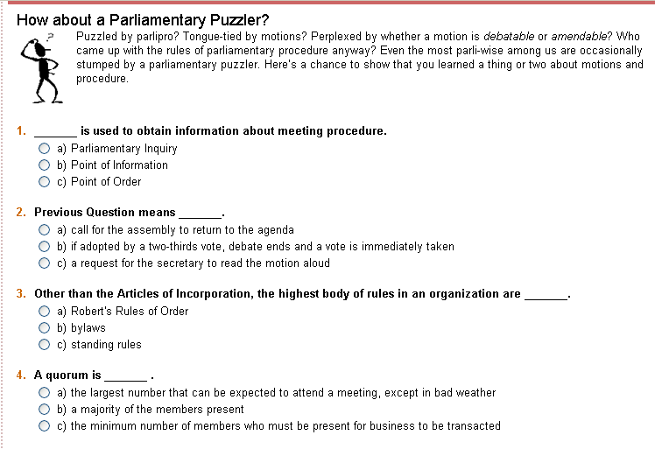
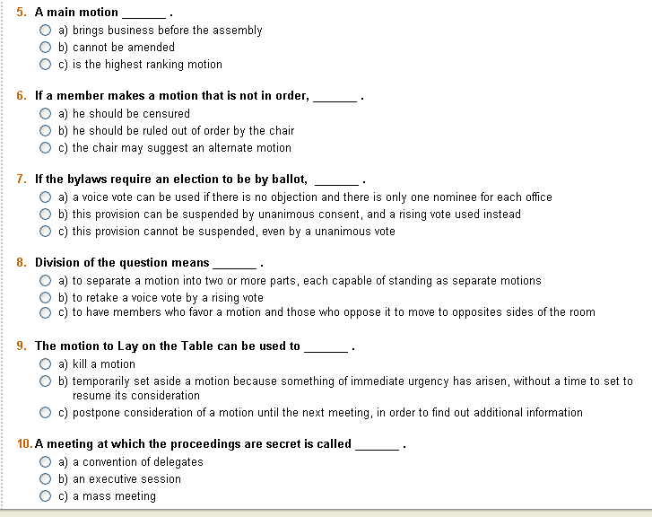
1. A Parliamentary Inquiry is used to obtain information about meeting procedure.
2. B Previous Question means if adopted by a two-thirds vote, debate ends and a vote is immediately taken.
3. B Other than the Articles of Incorporation, the highest body of rules in an organization are bylaws.
4. C A quorum is the minimum number of members who must be present for business to be transacted.
5. A A main motion brings business before the assembly.
6. C If a member makes a motion that is not in order the chair may suggest an alternate motion.
7. C If the bylaws require an election to be by ballot, this provision cannot be suspended, even by a unanimous vote.
8. A Division of the question means to separate a motion into two or more parts, each capable of standing as separate motions.
9. B The motion to Lay on the Table can be used to temporarily set aside a motion because something of immediate urgency has arisen, without a time to set to resume its consideration.
10. B A meeting at which the proceedings are secret is called an executive session.
http://www.rulesonline.com/index.html

Just The FAQ's (Frequently Asked Questions):
The answers here assume that RONR is the adopted parliamentary authority and that there are no bylaws, superior laws, or Special Rules of Order which supercede the rules in RONR:
- Can the chairman vote?
If a member, the chairman has the right to vote, and does so in small boards of not more than about a dozen members present. In larger assemblies, the chairman (who has a duty to maintain an appearance of impartiality) may vote when his vote would affect the outcome: to make or break a tie or to make or prevent a two-thirds vote, or when the vote is by ballot (at the same time as everybody else). RONR 10th ed. pp. 392-393.
- Can the chairman make motions?
Yes, the chairman, if a member, has the same RIGHT to make a motion as any other member. In small boards of not more than about a dozen members present, the chairman usually participates the same as other members. However, in larger assemblies, the chairman has a duty to remain impartial, so would usually not make a motion directly. The chairman could say, for example, "The chairman will entertain a motion to..." and then wait for a member to make it, or "Is there a motion to suspend the rules that interfere with hearing the speaker at this time?"
The chairman may also assume a motion, as in: "If there are no [further] corrections, the minutes stand approved as read [as corrected]." or "If there is no further business to come before the meeting, this meeting will now adjourn. [pause] Hearing none, this meeting is adjourned."
So you see, without actually directly making a motion, the chair can accomplish pretty much the same thing without blatantly compromising his or her impartiality. Another option is to ask someone before the meeting to make a motion that the chair wishes to be considered. After all, the chairman is a member, too, and has just as much right to have things go their way as any other member. Accepting the job of chairman does not remove any rights as a member. RONR 10th ed. pp. 470-471, 343, 210, 234, 490.
- Can the chairman enter into debate?
In small boards of not more than about a dozen members present, yes. In larger assemblies, if the chairman wishes to debate, he/she should relinquish the chair to the vice president or another member, until the matter is disposed of, before resuming the chair. RONR 10th ed. pp. 470-471, 382-383.
- Can an ex-officio member vote, make motions, or debate?
Yes, the term "ex officio", when no written rule addresses it otherwise, refers to a METHOD of sitting with a body, not a "class" of membership. It tells how one becomes a member (by virtue of the office), not what their rights are. If the rights of ex-officio members are to be restricted, that must be done in the bylaws. Otherwise, ex-officio members have the same rights as elected or appointed members. RONR 10th ed. pp. 466-467.
- Can bylaws be suspended?
Only bylaws that are in clearly in the nature of rules of order may be suspended. RONR 10th ed. p. 17.
- Can a member of the nominating committee be nominated?
Yes. For more information, refer to RONR 10th ed. p. 419.
- Can a member nominate themselves for an office?
Yes. There is no rule in RONR 10th ed. that prevents it.
- Can nominees vote for themselves?
Yes. There is no rule in RONR 10th ed. that prevents it.
- Must the President, if nominated, step down from the chair during the election?
No. For more information, refer to RONR 10th ed. pp. 436.
- Can a bylaws requirement for a ballot vote be suspended if there is only one nominee for each office?
No, such a bylaw cannot be suspended even by a unanimous vote or unanimous consent. RONR 10th ed. pp. 255 and 244.
- What is a write-in vote?
During a ballot vote, a member may write a name on the ballot, which is a vote for that person, rather than voting for a candidate whose name already appears on the ballot. RONR 10th ed. pp. 427.
- The President has resigned, now what?
The Vice-President automatically becomes the President for the remainder of the term of the President. RONR 10th ed. pp. 442.
- Are mail-in or telephone votes okay?
No, not unless authorized by the bylaws. RONR 10th ed. pp. 469-470.
- When somebody calls out "Question!" must debate cease?
No. Previous Question is the proper motion for that, and a member must be recognized by the chairman to move Previous Question, not just shout it out from their seat. If recognized and seconded, it is not debatable, and requires a two-thirds vote to be adopted. If adopted, debate ceases and a vote is taken on the immediately pending question. RONR 10th ed. pp. 189-201.
- When does a resignation take effect?
A resignation is actually a request to be excused from a duty. It is effective only after the resignation has been accepted by the appointing or electing authority, unless the bylaws say otherwise. RONR 10th ed. pp. 277-280.
- How long can a member speak in debate?
Ten minutes, unless he obtains the consent of the assembly to speak longer (two-thirds vote), and then a second time for 10 minutes after everyone has been given a chance to speak once. If debate is closed before the member has had a chance to make a speech or a second speech, none may be made. RONR 10th ed. pp. 41.
- Do nonmembers have a right to attend or speak at meetings?
No, nonmembers have no rights to the proceedings. However, a request can be granted to attend by a majority vote or unanimous consent, but it requires a two-thirds vote to suspend the rules to allow a nonmember to speak in debate. RONR 10th ed. pp. 255, 625.
- Do members who are not members of the Board of Directors have a right to be present or speak at board meetings?
No. See the answer to #17, as nonmembers have no rights to the proceedings of the Board.
- Do members of an organization have access to the minutes of the Board of Directors?
The Board may grant an individual member's request to inspect the minutes, or by a two-thirds vote or by a vote of a majority of the entire membership, the organization can order the minutes to be produced and read at a meeting, or by a majority vote if previous notice is given. RONR 10th ed. pp. 470.
- Should seconds be recorded in the minutes?
No. RONR 10th ed. pp. 451-456.
- If a motion has been defeated, can it be brought up again at the next meeting?
Yes, if the meeting is a different session, which is the normal situation, in other than legislative bodies. RONR 10th ed. pp. 325-331.
- Can a meeting be adjourned if there is still business pending?
Yes. RONR 10th ed. pp. 225-226.
- Who decides what is on the meeting Agenda?
The members at a meeting may adopt an agenda by a majority vote, and may amend it prior to its adoption. After it is adopted, an amendment to the Agenda requires a two-thirds vote, or a vote of a majority of the entire membership, or unanimous consent. RONR 10th ed. pp. 360-363.
- What is a quorum?
It is the minimum number of voting members who must be present at a meeting in order to conduct business, usually specified by the bylaws. If not specified in the bylaws, then in most societies a quorum is a majority of the entire membership. In a body of delegates, a quorum is a majority of the members registered as attending. In organizations without a reliable register of members, a quorum at a regular or properly called meeting is those who attend. In a mass meeting, a quorum is those persons present at the time. RONR 10th ed. pp. 334-335.
- What can be done in the absence of a quorum?
Fix the time to which to adjourn, Adjourn, Recess, Take measures to obtain a quorum. RONR 10th ed. pp. 336-337.
- How do you count abstentions? As ayes? As no's?
In the usual case, abstentions are not counted. They are not "votes" technically. In a room of 100 people, a vote of 1-0 [one affirmative and zero negative] is legitimate, and renders a binding decision. Also, A vote of 1-0 in room of 100 people is technically a "unanimous vote" because there was no vote in opposition. However, if the bylaws specify "a majority of those PRESENT" or "two-thirds of those PRESENT", instead of "PRESENT AND VOTING", then an abstention has the same effect as a negative vote. (This language is generally undesirable, as it denies a member the right maintain a neutral position by abstaining.) RONR 10th ed. p. 394 and p. 390.
- Can married couples be officers (or board members) at the same time?
Yes. Unless the bylaws say otherwise, there is no parliamentary rule to prevent it. Also, the voters have spoken, and saw nothing wrong there, too!
- What is a majority? Fifty-one percent? Fifty percent plus one?
The word "majority" means "more than half." The false definition "51%" only applies to units of exactly 100; the false definition of "50% + 1" is only true for even numbers, and false for odd numbers. RONR 10th ed. pp. 387.
- When nominations for offices are being taken from the floor, and in a situation in which the office calls for more than one person to be elected, can one make a nomination for more than one person at the same time?
No -- unless nobody objects. RONR (10th ed.), p. 418, l. 6-11.
- Can a member vote on or second a motion to approve the minutes of a meeting that he did not attend?
Yes, absolutely! There is no requirement in Robert's Rules of Order that a member have first-hand knowledge of something before voting on minutes or other motions. In fact, a motion need not be made regarding the approval of the minutes. The chair says, "Are there any corrections to the minutes?" Members may offer corrections, and when there are no further corrections forthcoming, the chair says, "If there are no further corrections to the minutes, they stand approved as corrected... the next item of business is..." or if no corrections are offered, "If there are no corrections to the minutes, they stand approved as read... the next item of business is..." Note that there is no second involved in this process. RONR (10th ed.), pp. 343-344.
- In the event of a tie vote what are the President's duties or options?
On a tie vote, a motion requiring a majority vote for adoption is lost, since a tie is not a majority.
If the presiding officer is a member of the assembly, he can vote as any other member when the vote is by ballot. In all other cases the presiding officer, if a member of the assembly, can (but is not obliged to) vote whenever his vote will affect the result--that is, he can vote either to break or to cause a tie; or, in a case where a two-thirds vote is required, he can vote either to cause or to block the attainment of the necessary two thirds.
The chair cannot vote twice, once as a member, then again in his capacity as presiding officer. In an appeal from the decision of the chair, a tie vote sustains the chair's decision, even though his vote created the tie, on the principle that the decision of the chair can be reversed only by a majority. RONR (10th ed.), pp. 392-393.
- How many times can minutes be corrected after they are approved?
There is no limit as far as Robert's Rules are concerned.
"If the existence of an error or material omission in the minutes becomes reasonably established after their approval—even many years later—the minutes can then be corrected by means of the motion to Amend Something Previously Adopted, which requires a two-thirds vote, or a majority vote with notice, or the vote of a majority of the entire membership, or unanimous consent." RONR 10th ed. p. 458.
- Does a treasurer's report need to have a motion of approval?
No motion is needed - or proper. A treasurer's report is simply "received" as it is given and no motion should be made to "adopt", "accept" or "approve" it. An annual auditors' report, on the other hand, is "accepted" or adopted, but not the treasurer's financial report itself. RONR 10th ed. p. 461.

The Standard Order of Business:
It is customary for every society having a permanent existence to adopt an order of business for its meetings. When no rule has been adopted, the following is the standard order of business:
- Reading and Approval of the Minutes of the Previous Meeting
- Reports of Officers, Boards, and Standing Committees
- Reports of Special (Select or Ad Hoc) Committees
- Special Orders
- Unfinished Business and General Orders*
- New Business

* The fifth item includes, first, the business pending and undisposed of at the previous adjournment; and then the general orders that were on the calendar for the previous meeting and were not disposed of; and finally, matters postponed to this meeting that have not been disposed of.

The secretary should prepare, prior to each meeting, a memorandum of the order of business for the use of the presiding officer, showing everything known in advance that is to come before the meeting. The chairman, as soon as one thing is disposed of, should announce the next business in order. RONR 10th ed. pp. 340-353.

Handling Motions:

- A member seeks recognition for the floor
- Chairman recognizes the member (member obtains the floor)
- Member makes a motion
- Another member seconds the motion
- Chairman states the question
- Debate (amendment and secondary motions)
- Chairman puts the question to a vote
- Chairman announces the result of the vote

What Precedes Debate:
Before a subject is open to debate, it is necessary for a motion to be made by a member who has obtained the floor; next it is seconded (with certain exceptions); and then it is stated by the chair (presiding officer). The fact that a motion has been made and seconded does not place it before the assembly for consideration, as the chair alone can do that. He must either rule it out of order, or state the question on it so that the assembly may know what is before it for consideration and action. If several questions are pending, as a resolution and an amendment and a motion to postpone, the last one stated by the chair is the "immediately pending" question.

Until the motion is stated or ruled out of order by the chair, no debate or other motion is in order. However, members may suggest modifications to the motion, and the mover, without the consent of the seconder, has the right to make such modifications as he pleases, or even to withdraw his motion entirely before the chair states the question. This is the case only for a brief interval, because after the question is stated by the chair, the mover can do neither without the consent of the assembly. A little informal consultation before the question is stated often saves much time, but the chair must see that this privilege is not abused and allowed to run into debate. When the mover modifies his motion, the one who seconded it has a right to withdraw his second. After debate has begun, a second is immaterial.

The procedure in small boards of not more than about a dozen members present is relaxed a bit. The formalities necessary in order to transact business in a large assembly would hinder business in so small a body. RONR 10th ed. pp. 31-54.

Precedence of Motions:
The motions rank as follows, from highest rank to lowest. When any of these motions is immediately pending, the motions above it in the list are in order, and those below are not in order.

Columns:
=Debatable
1 = Usually Privileged
2 = Not always privileged:
(a)-Privileged only when made while another question is pending, and in an assembly that has made no provision for another meeting on the same or the next day.
(b)-Loses its privileged character and is a main motion if in any way qualified, or if its effect, if adopted, is to dissolve the assembly without any provision for its meeting again.
(c)-Privileged only when made while other business is pending.
=Amendable
=Requires 2/3 vote for adoption; the others require only a majority
*=admissibility ruled upon by the Chair
**=No vote; demand of a single member
RONR 10th ed., tinted pages 1-29.
 | 1 | 2 |  |  | Motion
 | X | a |  |  | Fix the Time to which to Adjourn
 | X | b |  |  | Adjourn
 | X | c |  |  | Recess
 | X |  |  | * | Raise a Question of Privilege
 | X |  |  | ** | Call for the Orders of the Day
 |  |  |  |  | Lay on the Table
 |  |  |  |  | Previous Question
 |  |  |  |  | Limit or Extend Limits of Debate
 |  |  |  |  | Postpone to a Certain Time
 |  |  |  |  | Commit or Refer
 |  |  |  |  | Amend
 |  |  |  |  | Postpone Indefinitely
 |  |  |  |  | Main Motion

Precedence of Motions:
The Ranking Motions in Order of Precedence:

- Fix the Time to Which to Adjourn
- Adjourn
- Recess
- Raise a Question of Privilege
- Call for the Orders of the Day
- Lay on the Table
- Previous Question
- Limit or Extend Limits of Debate
- Postpone to a Certain Time
- Commit or Refer
- Amend
- Postpone Indefinitely
MAIN MOTION

1. FIX THE TIME TO WHICH TO ADJOURN
This motion is privileged only when made while another question is pending and in an assembly that has made no provision for another meeting on the same or the next day. The time fixed cannot be beyond the time of the next meeting. If made in an assembly that already has provided for another meeting on the same or the next day, or if made in an assembly when no question is pending, this is a main motion and may be debated and amended and have applied to it the other subsidiary motions, like other main motions. Whenever the motion is referred to in these rules the privileged motion is meant, unless specified to the contrary. This motion when privileged takes precedence of all others, and is in order even after it has been voted to adjourn, provided the chairman has not declared the assembly adjourned. It can be amended, and a vote on it can be reconsidered. When the assembly has no fixed place for its meetings, this motion should include the place as well as the time for the next meeting, and in this case the place is subject to amendment as well as the time. When the assembly meets at the time to which it adjourned, the meeting is a continuation of the previous session. Thus, if the Annual Meeting is adjourned to meet on another day, the adjourned meeting is a legal continuation of the Annual Meeting. The form of this motion is, I move that when we adjourn, we adjourn (or stand adjourned) to 2 P.M. tomorrow.

2. ADJOURN
The motion to adjourn (when unqualified) is always a privileged motion except when, for lack of provision for a future meeting, as in a mass meeting, or at the last meeting of a convention, its effect, if adopted, would be to dissolve the assembly permanently. In any organized society holding several regular meetings during the year, it is, when unqualified, always a privileged motion. When not privileged it is treated as any other main motion, being debatable and amendable, etc. The motion to adjourn, like every other motion, cannot be made except by a member who has the floor. When made by one who has not risen and addressed the chair and been recognized, it can be entertained only by general consent. It cannot be made when the assembly is engaged in voting, or verifying the vote, but is in order after the vote has been taken by ballot before it has been announced. In such case the ballot vote should be announced as soon as business is resumed. Where much time will be consumed in counting ballots the assembly may adjourn, having previously appointed a time for the next meeting, or, still better, may take a recess as explained in the next section. No appeal, or question of order, or inquiry, should be entertained after the motion to adjourn has been made, unless it is of such a nature that its decision is necessary before an adjournment, or unless the assembly refuses to adjourn, when it would be in order. When the motion to adjourn is qualified in any way, or when its effect is to dissolve the assembly without any provision being made for holding another meeting of the assembly, it loses its privilege and is a main motion, debatable and amendable and subject to having applied to it any of the subsidiary motions.

3. RECESS
This motion is practically a combination of the two preceding, to which it yields, taking precedence of all other motions. If made when other business is before the assembly, it is a privileged motion and is undebatable and can have no subsidiary motion applied to it except amend. It can be amended as to the length of the recess. It takes effect immediately. A motion to take a recess made when no business is before the assembly, or a motion to take a recess at a future time, has no privilege, and is treated as any other main motion. A recess is an intermission in the day's proceedings, as for meals or for counting the ballots when much time is required; or in the case of meetings like conventions lasting for several days a recess is sometimes taken over an entire day. When a recess is provided for in the order of exercises, or program, the chair, when the time arrives, announces the fact and says the assembly stands adjourned, or in recess, to the specified hour. The assembly by a two-thirds vote can postpone the time for taking a recess, or adjournment. When the hour has arrived to which the recess was taken, the chairman calls the assembly to order and the business proceeds the same as if no recess had been taken. If the recess was taken after a vote had been taken and before it was announced, then the first business is the announcement of the vote. The intermissions in the proceedings of a day are termed recesses, whether the assembly voted to take a recess, or whether it simply adjourned having previously adopted a program or rule providing for the hours of meeting. When an assembly has frequent short regular meetings not lasting over a day, and an adjourned meeting is held on another day, the interval between the meetings is not referred to as a recess.

4. RAISE A QUESTION OF PRIVILEGE
Questions relating to the rights and privileges of the assembly, or to any of its members, take precedence of all other motions except the three preceding relating to adjournment and recess, to which they yield. If the question is one requiring immediate action it may interrupt a member's speech; as, for example, when, from any cause, a report that is being read cannot be heard in a part of the hall. But if it is not of such urgency it should not interrupt a member after he has commenced his speech. Before a member has commenced speaking, even though he has been assigned the floor, it is in order for another member to raise a question of privilege.

5. CALL FOR THE ORDERS OF THE DAY
A Call for the Orders of the Day (which, in an ordinary assembly, is a demand that the assembly conform to its program or order of business) can be made at any time when no other privileged motion is pending and the order of business is being varied from, and only then. It requires no second, and is in order when another has the floor, even though it interrupts a speech, as a single member has a right to demand that the order of business be conformed to. It is out of order to call for the orders of the day when there is no variation from the order of business. Thus, the orders of the day cannot be called for when another question is pending, provided there are no special orders made for that time or an earlier time, as general orders cannot interrupt a question actually under consideration. The call must be simply for the orders of the day, and not for a specified one, as the latter has no privilege. When the time has arrived for which a special order has been made, a call for the orders of the day taken precedence of everything except the other privileged motions, namely, those relating to adjournment and recess, and questions of privilege, to which it yields. If there are no special orders a call for the orders of the day cannot interrupt a pending question; but, if made when no question is pending, it is in order even when another has the floor an has made a main motion, provided the chair has not stated the question. Until the time of actually taking up the general orders for consideration this call yields to a motion to reconsider, or to a calling up of a motion to reconsider, previously made. A call for the orders of the day cannot be debated or amended, or have any other subsidiary motion applied to it.

6. LAY ON THE TABLE
The Object of this motion is to enable the assembly, in order to attend to more urgent business, to lay aside the pending question in such a way that its consideration may be resumed at the will of the assembly as easily as if it were a new question, and in preference to new questions competing with it for consideration. It is to the interest of the assembly that this object should be attained instantly by a majority vote, and therefore this motion must either apply to, or take precedence of, every debatable motion whatever its rank. It is undebatable, and requires only a majority vote, notwithstanding the fact that if not taken from the table the question is suppressed. These are dangerous privileges which are given to no other motion whose adoption would result in final action on a main motion. There is a great temptation to make an improper use of them, and lay questions on the table for the purpose of instantly suppressing them by a majority vote, instead of using the previous question, the legitimate motion to bring the assembly to an immediate vote. The fundamental principles of parliamentary law require a two-thirds vote for every motion that suppresses a main question for the session without free debate. The motion to lay on the table being undebatable, and requiring only a majority vote, and having the highest rank of all subsidiary motions, is in direct conflict with these principles, if used to suppress a question. If habitually used in this way, it should, like the other motions to suppress without debate, require a two-thirds vote.

7. PREVIOUS QUESTION
The Effect of ordering the previous question is to close debate immediately, to prevent the moving of amendments or any other subsidiary motions except to lay on the table, and to bring the assembly at once to a vote on the immediately pending question, and such other pending questions as were specified in the demand, or motion. If the previous question is ordered on more than one question, then its effect extends to those questions and is not exhausted until they are voted on, or they are disposed of as shown below under exhaustion of the previous question. If the previous question is voted down, the discussion continues as if this motion had not been made. The effect of the previous question does not extend beyond the session in which it was adopted. Should any of the questions upon which it was ordered come before the assembly at a future session they are divested of the previous question and are open to debate and amendment.

8. LIMIT OR EXTEND LIMITS OF DEBATE
Motions, or orders, to limit or extend the limits of debate, like the previous question, take precedence of all debatable motions, may be applied to any debatable motion or series of motions, and, if not specified to the contrary, apply only to the immediately pending question. If it is voted to limit the debate, the order applies to all incidental and subsidiary motions and the motion to reconsider, subsequently made, as long as the order is in force. But an order extending the limits of debate does not apply to any motions except the immediately pending one and such others as are specified. They are undebatable, and require a two-thirds vote for their adoption.

9. POSTPONE TO A CERTAIN TIME
The Effect of postponing a question is to make it an order of the day for the time to which it was postponed, and if it is not then disposed of, it becomes unfinished business. Postponing a question to a certain hour does not make it a special order unless so specified in the motion.

10. COMMIT OR REFER
The Object of the motion to refer to a standing or special committee is usually to enable a question to be more carefully investigated and put into better shape for the assembly to consider, than can be done in the assembly itself. Where an assembly is large and has a very large amount of business it is safer to have every main question go to a committee before final action on it is taken. A special committee to investigate and report upon a subject should consist of representative members on both sides of the question, so that both parties in the assembly may have confidence in the report, or reports in case there is disagreement and a minority report is submitted.

11. AMEND
An amendment is debatable in all cases except where the motion to be amended is undebatable. An amendment of a pending question requires only a majority vote for its adoption, even though the question to be amended requires a two-thirds vote. An amendment of a constitution or by-laws, or rules of order, or order of business, previously adopted, requires a two-thirds vote; but an amendment of that amendment requires only a majority vote. When a motion or resolution is under consideration only one amendment of the first degree is permitted at a time, and one amendment of that amendment -- that is, an amendment of the second degree is allowed also. An amendment of the third degree would be too complicated and is not in order. Instead of making it, a member may say that if the amendment of the amendment is voted down, he will offer such and such an amendment of the amendment. While there can be only one amendment of each degree pending at the same time, any number of them may be offered in succession. An amendment must be germane to the subject to be amended -- that is, it must relate to it, as shown further on. So an amendment to an amendment must be germane to the latter.

12. POSTPONE INDEFINITELY
The Object of this motion is not to postpone, but to reject, the main motion without incurring the risk of a direct vote on it, and it is made only by the enemies of the main motion when they are in doubt as to their being in the majority.

MAIN MOTION
Is a motion made to bring before the assembly, for its consideration, any particular subject. It takes precedence of nothing -- that is, it cannot be made when any other question is before the assembly; and it yields to all Privileged, Incidental, and Subsidiary Motions -- that is, any of these motions can be made while a main motion is pending. Main motions are debatable, and subject to amendment, and can have any subsidiary motions applied to them. When a main motion is laid on the table, or postponed to a certain time, it carries with it all pending subsidiary motions. If a main motion is referred to a committee it carries with it only the pending amendments. As a general rule, they require for their adoption only a majority vote -- that is, a majority of the votes cast; but amendments to constitutions, by-laws, and rules of order already adopted, all of which are main motions, require a two-thirds vote for their adoption, unless the by-laws, etc., specify a different vote for their amendment; and the motion to rescind action previously taken requires a two-thirds vote, or a vote of a majority of the entire membership, unless previous notice of the motion has been given.

For additional information, refer to RONR 10th ed., tinted pages 1-29.

Quorum
A Quorum of an assembly is such a number as must be present in order that business can be legally transacted. The quorum refers to the number present, not to the number voting. The quorum of a mass meeting is the number present at the time, as they constitute the membership at that time. The quorum of a body of delegates, unless the by-laws provide for a smaller quorum, is a majority of the number enrolled as attending the convention, not those appointed. The quorum of any other deliberative assembly with an enrolled membership (unless the by-laws provide for a smaller quorum) is a majority of all the members.

In the case, however, of a society, like many religious ones, where there are no annual dues, and where membership is for life (unless it is transferred or the names are struck from the roll by a vote of the society) the register of members is not reliable as a list of the bona fide members of the society, and in many such societies it would be impossible to have present at a business meeting a majority of those enrolled as members. Where such societies have no by-law establishing a quorum, the quorum consists of those who attend the meeting, provided it is either a stated meeting or one that has been properly called.

In all ordinary societies the by-laws should provide for a quorum as large as can be depended upon for being present at all meetings when the weather is not exceptionally bad. In such an assembly the chairman should not take the chair until a quorum is present, or there is no prospect of there being a quorum. The only business that can be transacted in the absence of a quorum is
- to take measures to obtain a quorum,
- to fix the time to which to-adjourn, and
- to adjourn, or
- to take a recess.

Unanimous consent cannot be given when a quorum is not present, and a notice given then is not valid. In the case of an annual meeting, where certain business for the year, as the election of officers, must be attended to during the session, the meeting should fix a time for an adjourned meeting and then adjourn.

For additional information, refer to RONR 10th ed. pp. 334-340.

Roberts Rules FAQ.
http://www.robertsrules.com/faq.html

Is it true that the president can vote only to break a tie?
No, it is not true that the president can vote only to break a tie. If the president is a member of the assembly, he or she has exactly the same rights and privileges as all other members have, including the right to make motions, speak in debate and to vote on all questions. However, the impartiality required of the presiding officer of an assembly (especially a large one) precludes exercising the right to make motions or debate while presiding, and also requires refraining from voting except (i) when the vote is by ballot, or (ii) whenever his or her vote will affect the result.
When will the chair's vote affect the result? On a vote which is not by ballot, if a majority vote is required and there is a tie, he or she may vote in the affirmative to cause the motion to prevail. If there is one more in the affirmative than in the negative, he or she can create a tie by voting in the negative to cause the motion to fail. Similarly, if a two-thirds vote is required, he or she may vote either to cause, or to block, attainment of the necessary two thirds. [RONR (10th ed.), p. 392-93; see also Table A, p.190 of RONR In Brief.]

Can ex-officio members vote, and are they counted in determining whether a quorum is present?
"Ex officio" is a Latin term meaning "by virtue of office or position." Ex-officio members of boards and committees, therefore, are persons who are members by virtue of some other office or position that they hold. For example, if the bylaws of an organization provide for a Committee on Finance consisting of the treasurer and three other members appointed by the president, the treasurer is said to be an ex-officio member of the finance committee, since he or she is automatically a member of that committee by virtue of the fact that he or she holds the office of treasurer.
Without exception, ex-officio members of boards and committees have exactly the same rights and privileges as do all other members, including, of course, the right to vote. There are, however, two instances in which ex-officio members are not counted in determining the number required for a quorum or in determining whether or not a quorum is present. These two instances are:
1. In the case of the president, whenever the bylaws provide that the president shall be an ex-officio member of all committees (except the nominating committee); and
2. If the ex-officio member is not a member, officer, or employee of the society (for example, when the governor of a state is made ex officio a member of a private college board).
Again, however, it should be emphasized that in these instances the ex-officio member still has all of the rights and privileges of membership, including the right to vote. [RONR (10th ed.), p. 466-67; p. 480, l. 18-27.]

Is it true that, once a quorum has been established, it continues to exist no matter how many members leave during the course of the meeting?
No. Once a quorum at a meeting has been established, the continued presence of a quorum is presumed to exist only until the chair or any other member notices that a quorum is no longer present. If the chair notices the absence of a quorum, he or she should declare this fact, at least before taking any vote or stating the question on any new motion. Any member noticing the apparent absence of a quorum can and should make a Point of Order to that effect whenever another person is not speaking. It is dangerous to allow the transaction of substantive business to continue in the absence of a quorum. Although a Point of Order relating to the absence of a quorum is generally not permitted to affect prior action, if there is clear and convincing proof no quorum was present when business was transacted, the presiding officer can rule that business invalid (subject to appeal). [RONR (10th ed.), p. 337-38; see also p. 12-13 of RONR In Brief.]

In determining the result of a vote, what constitutes a majority?
The word "majority" in this context means, simply, more than half. The use of any other definition, such as 50 percent plus one, is apt to cause problems. Suppose in voting on a motion 17 votes are cast, 9 in favor and 8 opposed. Fifty percent of the votes cast is 8 1/2, so that 50 percent plus one would be 9 1/2. Under such an erroneous definition of a majority, one might say that the motion was not adopted because it did not receive fifty percent plus one of the votes cast, although it was, quite clearly, passed by a majority vote. [RONR (10th ed.), p. 387; see also p. 66 of RONR In Brief.]

Can we round to the nearest number in computing the result of a vote? For example, since two thirds of 101 is 67.3333, will 67 affirmative votes out of 101 votes cast meet the requirement of a two-thirds vote?
No. The requirement of a two-thirds vote means at least two thirds. As a consequence, nothing less will do. If 101 votes are cast, 67 affirmative votes are not at least two thirds. It is less than two thirds, and will not suffice. [RONR (10th ed.), p. 388.]

Do abstention votes count?
The phrase "abstention votes" is an oxymoron, an abstention being a refusal to vote. To abstain means to refrain from voting, and, as a consequence, there can be no such thing as an "abstention vote."
In the usual situation, where either a majority vote or a two-thirds vote is required, abstentions have absolutely no effect on the outcome of the vote since what is required is either a majority or two thirds of the votes cast. On the other hand, if the vote required is a majority or two thirds of the members present, or a majority or two thirds of the entire membership, an abstention will have the same effect as a "no" vote. Even in such a case, however, an abstention is not a vote. [RONR (10th ed.), p. 387, l. 7-13; p. 388, l. 3-6; p. 390, l. 13-24; see also p.66 of RONR In Brief.]

What is a vote of no confidence?
The term "vote of no confidence" is not used or defined anywhere in RONR, and there is no mention of any motion for such a vote. However, this does not mean that an assembly cannot adopt a motion, if it wishes, expressing either its confidence or lack of confidence in any of its officers or subordinate boards or committees. Any such motion would simply be a main motion, and would have no effect other than to express the assembly's views concerning the matter. A vote of "no confidence" does not - as it would in the British Parliament - remove an officer from office.

How do you deal with a "friendly amendment"?
On occasion, while a motion is being debated, someone will get up and offer what he or she terms a "friendly amendment" to the motion, the maker of the original motion will "accept" the amendment, and the chair will treat the motion as amended. This is wrong. Once a motion has been stated by the chair, it is no longer the property of the mover, but of the assembly. Any amendment, "friendly" or otherwise, must be adopted by the full body, either by a vote or by unanimous consent.
If it appears to the chair that an amendment (or any other motion) is uncontroversial, it is proper for the chair to ask if there is "any objection" to adopting the amendment. If no objection is made, the chair may declare the amendment adopted. If even one member objects, however, the amendment is subject to debate and vote like any other, regardless of whether its proposer calls it "friendly" and regardless of whether the maker of the original motion endorses its adoption. [RONR (10th ed.), p. 154.]

Isn't it true that a member who has a conflict of interest with respect to a motion cannot vote on the motion?
Under the rules in RONR, no member can be compelled to refrain from voting simply because it is perceived that he or she may have some "conflict of interest" with respect to the motion under consideration. If a member has a direct personal or pecuniary (monetary) interest in a motion under consideration not common to other members, the rule in RONR is that he should not vote on such a motion, but even then he or she cannot be compelled to refrain from voting. [RONR (10th ed.), p. 394, l. 15-25.]

Should proxy votes be counted?
A "proxy" is a means by which a member who expects to be absent from a meeting authorizes someone else to act in his or her place at the meeting. Proxy voting is not permitted in ordinary deliberative assemblies unless federal, state or other laws applicable to the society require it, or the bylaws of the organization authorize it, since proxy voting is incompatible with the essential characteristics of a deliberative assembly. As a consequence, the answers to any questions concerning the correct use of proxies, the extent of the power conferred by a proxy, the duration, revocability, or transferability of proxies, and so forth, must be found in the provisions of the law or bylaws which require or authorize their use. [RONR (10th ed.), p. 414-15.]

Must debate on a motion stop immediately as soon as any member calls the question?
It is a fairly common misconception that, after debate has continued for some time, if any member shouts out "Question!" or "I call the question!", debate must immediately cease and the chair must put the pending question to a vote. This is simply not the case. Any member who wishes to force an end to debate must first obtain the floor by being duly recognized to speak by the chair, and must then move the Previous Question. Such a motion must be seconded, and then adopted by a two-thirds vote, or by unanimous consent. It is not in order to interrupt a speaker with cries of "Question" or "Call the Question," and even if no one is speaking, it is still necessary to seek recognition. [RONR (10th ed.), p. 193-94; see also p 35-37 of RONR In Brief.]

Isn't it always in order to move to table a motion to the next meeting?
This question confuses the motion to Lay on the Table with the motion to Postpone to a Certain Time. The purpose of the motion to Lay on the Table is to enable an assembly, by majority vote and without debate, to lay a pending question aside temporarily in order to take up something else of immediate urgency. In ordinary societies it is rarely needed, and hence seldom in order. [RONR (10th ed.), p. 201-210; see also p. 127 of RONR In Brief.]

Can something be defeated by adopting a motion to table it?
This is a common violation of fair procedure. Such a motion is not in order, because it would permit debate to be suppressed by a majority vote, and only a two-thirds vote can do that. The proper use of the motion to Lay on the Table is stated in the answer to Question 12, immediately above. [RONR (10th ed.), p. 207-209.]
How can something be defeated without a direct vote on it?
Before debate on an original (ordinary substantive) main motion has begun you may raise an Objection to Consideration of [the] Question, which is undebatable and can suppress the main question by a two-thirds vote against consideration. [RONR (10th ed.), p. 209, l. 1-4; p. 258-61; see also p. 129 of RONR In Brief.]
If debate on the main motion has begun and you want to get rid of that motion without a direct vote on it, use the motion to Postpone Indefinitely. That motion requires only a majority vote, but until it is adopted, it leaves the main question open to debate. [RONR (10th ed.), p. 121-24; see also p. 126 of RONR In Brief.] If you feel that it is undesirable that debate take place, move the Previous Question immediately after moving to Postpone Indefinitely. If adopted by a two-thirds vote, this motion will cause an immediate vote on the motion to Postpone Indefinitely without further debate. [RONR (10th ed.), p. 189-201.]

How can I get an item on the agenda for a meeting?
For a proposed agenda to become the official agenda for a meeting, it must be adopted by the assembly at the outset of the meeting. At the time that an agenda is presented for adoption, it is in order for any member to move to amend the proposed agenda by adding any item which the member desires to add, or by proposing any other change.
It is wrong to assume, as many do, that the president "sets the agenda." It is common for the president to prepare a proposed agenda, but that becomes binding only if it is adopted by the full assembly, perhaps after amendments as just described. [RONR (10th ed.), p. 363, l. 8-20; see also p. 16 of RONR In Brief.]

Isn't it necessary to summarize matters discussed at a meeting in the minutes of that meeting in order for the minutes to be complete?
Not only is it not necessary to summarize matters discussed at a meeting in the minutes of that meeting, it is improper to do so. Minutes are a record of what was done at a meeting, not a record of what was said. [RONR (10th ed.), p. 451, l. 25-28; see also p. 146 of RONR In Brief.]

If minutes of a previous meeting are corrected, are the corrections entered in the minutes of the meeting at which the corrections were made?
If corrections to minutes are made at the time when those minutes are originally submitted for approval, such corrections are made in the text of the minutes being approved. The minutes of the meeting at which the corrections are made should merely indicate that the minutes were approved "as corrected."
If it becomes necessary to correct minutes after they have initially been approved, such correction can be made by means of the motion to Amend Something Previously Adopted. In this event, since the motion to Amend Something Previously Adopted is a main motion, the exact wording of that motion, whether adopted or rejected, should be entered in the minutes of the meeting at which it was considered. [RONR (10th ed.), p. 452, l. 12-15; p. 458, l. 10-16; see also p.151 of RONR In Brief.]

Can votes be taken in an executive session?
Yes, votes can be taken in executive session. Proceedings in an executive session are secret, but are not restricted in any other way. [RONR (10th ed.), p. 92-93.]

Is it possible to withdraw a resignation after it has been submitted?
A resignation is a Request to Be Excused from a Duty. It may be withdrawn in the same manner as any motion may be withdrawn - that is to say, before the proposed resignation has been placed before the assembly by the chair stating the question on its acceptance, it may be withdrawn without the consent of the assembly, but it may not be withdrawn without permission of the assembly once it has been placed before the assembly for its approval. [RONR (10th ed.), p. 277-80; 283-85.]

Can we hold our board meetings by conference telephone call?
You may hold board meetings by conference telephone call only if your bylaws specifically authorize you to do so. If they do, such meetings must be conducted in such a way that all members participating can hear each other at the same time, and special rules should be adopted to specify precisely how recognition is to be sought and the floor obtained during such meetings. [RONR (10th ed.), p. 482, l. 28, to p. 483, l. 5; see also p. 159 of RONR In Brief.]
It should be noted in this connection that the personal approval of a proposed action obtained from a majority of, or even all, board members separately is not valid board approval, since no meeting was held during which the proposed action could be properly debated. If action is taken by the board on the basis of individual approval, such action must be ratified by the board at its next regular meeting in order to become an official act. [RONR (10th ed.), p. 469, l. 24, to p. 470, l. 2.]

How can we get rid of officers we don't like before their term is up?
It depends. If the bylaws just state a fixed term for the officer, such as "two years," or if they say the officer serves for a specified term "and until [the officer's] successor is elected" (or words to that effect), then the group must use formal disciplinary proceedings, which involve the appointment of an investigating committee, preferral of charges by such a committee, and the conduct of a formal trial. The procedure is complex, and should be undertaken only after a careful review of Chapter XX of RONR.
On the other hand, if the bylaws state a term for the office but add "or until [the officer's] successor is elected," or contain other wording explicitly indicating that the officer may be removed before the term expires, then the election can be rescinded (see Chapter 7 of RONR In Brief) and a successor then elected for the remainder of the term.
Of course, if the bylaws themselves establish a procedure for removal from office, that procedure must be followed. [RONR (10th ed.), p. 642-43.]

The Minutes:
The record of the proceedings of a deliberative assembly is usually called the Minutes, or the Record, or the Journal. In the meetings of ordinary societies, there is no object in reporting the debates; the duty of the secretary, in such cases, is mainly to record what is "done" by the assembly, and not what is said by the members. The minutes should show:
- Kind of meeting, "regular" (or stated) or "special," or "adjourned regular" or "adjourned special";
- Name of the organization or assembly;
- Date/time of meeting and place, when it is not always the same;
- The fact of the presence of the regular chairman and secretary, or in their absence the names of their substitutes,
- Whether the minutes of the previous meeting were read and approved, or approved as corrected, and the date of the meeting if other than a regular business meeting;
- All main motions (except such as were withdrawn) and motions that bring a main question again before the assembly, stating the wording as adopted or disposed of, and the disposition--including temporary disposition (with any primary and secondary amendments and adhering secondary motions then pending;
- Secondary motions not lost or withdrawn where needed for clarity of the minutes;
- Previous notice of motions;
- Points of order and appeals, and reasons the chair gives for the ruling;
- Time of adjournment.

Generally the name is recorded of the mover, but not of the seconder, unless ordered by the assembly. When corrections to the minutes are made by the assembly, the corrections are made in the written text of the minutes being approved, and the minutes of the meeting where they are corrected merely state that the minutes were approved “as corrected”, without actually stating the details of those corrections.

The secretary should sign the minutes, and in some societies the minutes are also signed by the president. When the minutes are approved, the word "Approved" should be written on the minutes with the secretary’s initials and the date.

The essentials of a record should be entered, as previously stated, and when a count has been ordered or where the vote is by ballot, the number of votes on each side should be entered. When the voting is by roll call, a list of the names of those voting on each side should be entered, and those answering “Present”, and enough names of those present, who fail to respond, to reflect that a quorum was present.

Where the regular meetings are held weekly, monthly, or quarterly, the minutes are read at the opening of each day's meeting, and, after correction should be approved. Where the meetings are held several days in succession with recesses during the day, the minutes are read at the opening of business each day. If the next meeting of the organization will not be held for a long period, as six months or a year, the minutes that have not been read previously should be read and approved before final adjournment. If this is not practical, then the executive committee or a special committee should be authorized to correct and approve them. A special meeting does not approve minutes, and its minutes should be approved at the next regular meeting.

When the reading of the minutes is dispensed with they can afterwards be taken up at any time when nothing is pending. If not taken up previously, they come before the assembly at the next meeting before the reading of the later minutes. For additional information, refer to RONR 10th ed. pp. 451-458.

Robert's Rules says that all MAIN motions should be shown in the minutes. However, at a meeting, the secretary will have a need to record nearly all motions and what was done (their disposition), recording details that are not intended to show up in the final draft to be submitted for approval at the next regular meeting.

These notes will then be edited and condensed so that secondary motions, e.g. amendments, are not listed separately in the minutes, but are incorporated into the final wording that is the exact same wording used by the chair in putting the question to a vote and/or otherwise disposing of the main motion. The final draft will show all MAIN motions, as amended, and will not show the evolution of the wording of a motion during its amendment. Thus, a half-dozen handwritten pages may become a single typewritten page.

For example, the final draft minutes may be worded as follows:
After amendment, a motion by H.M. Robert was adopted, "that the club purchase a new laptop computer for use by the secretary in preparing minutes and other correspondence, at a cost not to exceed $2,500."
The fact that the motion was amended is mentioned only parenthetically, without providing details.

Some expanded explanations:
Lay on the Table
Previous Question
Postpone to a Certain Time (Postpone Definitely)
Postpone Indefinitely
Take from the Table

Lay on the Table
Rod G Davidson, Professional Registered Parliamentarian www.parlipro.org
Puzzled by the motion to Lay on the Table? After you complete this online module and take the short quiz to test your understanding and refresh your memory, you will feel more confident about this parliamentary puzzler. Here’s a chance to learn a thing or two about the motion to Lay on the Table, courtesy of the public domain version of Robert's Rules of Order Revised, Fourth Edition.

The motion to Lay on the Table is undebatable and cannot have any subsidiary motion applied to it. It may be applied to any main motion; to any question of privilege or order of the day, after it is before the assembly for consideration; to an appeal that does not adhere to the main question. No motion that has another motion adhering to it can be laid on the table by itself; if laid on the table it carries with it everything that adheres to it.

When a motion is taken from the table everything is in the same condition, as far as practicable, as when the motion was laid on the table, except that if not taken up until the next session the effect of the previous question is exhausted. If debate has been closed by ordering the previous question, or otherwise, up to the moment of taking the last vote under the order, the questions still before the assembly may be laid on the table.

This motion cannot be applied to anything except a question actually pending, therefore it is not in order to lay on the table a class of questions, as the orders of the day, or unfinished business, or reports of committees, because they are not pending questions, as only one main motion can be pending at a time. To accomplish the desired object, which is evidently to reach a special subject or class of business, the proper course is to suspend the rules by a two-thirds vote and take up the desired question or class of business.

If a motion to lay on the table has been made and lost, or if a question laid on the table has been taken from the table, it shows that the assembly wishes to consider the question now, and therefore a motion made the same day to lay that question on the table is out of order until there has been material progress in business or debate, or unless an unforeseen urgent matter requires immediate attention.

The assembly cannot be required to vote again the same day on laying the question on the table unless there is such a change in the state of affairs as to make it a new question. A vote on laying on the table cannot be reconsidered, because, if lost the motion may be renewed as soon as there has been material progress in debate or business, or even before if anything unforeseen occurs of such an urgent nature as to require immediate attention; and if adopted the question may be taken from the table as soon as the interrupting business has been disposed of and while no question is pending, and business of this class, or new or unfinished business, is in order.

The Form of this motion is:
"I move to lay the question on the table."
or
"I move that the question be laid on the table."
It cannot be qualified in any way; if it is qualified, thus, "To lay the question on the table until 2 P.M.," the chair should state it properly as a motion to postpone until 2 P.M., which is a debatable question, and is not the motion to Lay on the Table.

Purpose:
The Object of this motion is to enable the assembly, in order to attend to more urgent business, to lay aside the pending question in such a way that its consideration may be resumed at the will of the assembly as easily as if it were a new question, and in preference to new questions competing with it for consideration. It is to the interest of the assembly that this object should be attained instantly by a majority vote, and therefore this motion must either apply to, or take precedence of, every debatable motion whatever its rank.

The motion to Lay on the Table is undebatable, and requires only a majority vote, notwithstanding the fact that if not taken from the table the question is suppressed.

These are dangerous privileges which are given to no other motion whose adoption would result in final action on a main motion. There is a great temptation to make an improper use of them, and lay questions on the table for the purpose of instantly suppressing them by a majority vote, instead of using the previous question, the legitimate motion to bring the assembly to an immediate vote.

The fundamental principles of parliamentary law require a two-thirds vote for every motion that suppresses a main question for the session without free debate. The motion to lay on the table being undebatable, and requiring only a majority vote, and having the highest rank of all subsidiary motions, is in direct conflict with these principles, if used to suppress a question. If habitually used in this way, it should, like the other motions to suppress without debate, require a two-thirds vote. [Note: The current (Tenth) edition of Robert's Rules of Order Newly Revised, does not permit this usage of Lay on the Table to suppress a question.]

As motions laid on the table are merely temporarily laid aside, the majority should remember that the minority may all stay to the moment of final adjournment and then be in the majority, and take up and pass the resolutions laid on the table. They may also take the question from the table at the next meeting in societies having regular meetings as frequently as quarterly. If not taken from the table at the next meeting, however, the motion dies.

Effect:
The Effect of the adoption of this motion is to place on the table, that is, in charge of the secretary, the pending question and everything adhering to it; so, if an amendment is pending to a motion to refer a resolution to a committee, and the question is laid on the table, all these questions go together to the table, and when taken from the table they all come up together.

In legislative bodies, and all others that do not have regular sessions as often as quarterly, questions laid on the table remain there for that entire session, unless taken up before the session closes. In deliberative bodies with regular sessions as frequent as quarterly, the sessions usually are very short and questions laid on the table remain there until the close of the next regular session, if not taken up earlier; just as in the same assemblies a question can be postponed to the next session, and the effect of the motion to reconsider, if not called up, does not terminate until the close of the next session.

While a question is on the table no motion on the same subject is in order that would in any way affect the question that is on the table; it is necessary first to take the question from the table and move the new one as a substitute, or to make such other motion as is adapted to the case.

Now, test your understanding of the motion to Lay on the Table. Answer the questions below and then click the button underneath to see your results. Good luck!
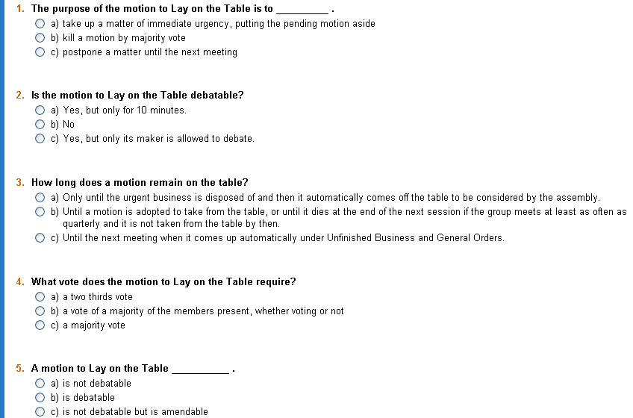
  - A The purpose of the motion to Lay on the Table is to take up a matter of immediate urgency, putting the pending motion aside.
  - B The motion to Lay on the Table is not debatable.
  - B The motion that is laid on the table remains there until a motion is adopted to Take from the Table, or until it dies at the end of the next session if the group meets at least as often as quarterly and it is not taken from the table by then.
  - C The motion to Lay on the Table requires a majority vote.
  - A A motion to Lay on the Table is not debatable or amendable.

Previous Question
Rod G Davidson, Professional Registered Parliamentarian www.parlipro.org
Puzzled by the motion Previous Question? After you complete this online module and take the short quiz to test your understanding and refresh your memory, you will feel more confident about this parliamentary puzzler. Here’s a chance to learn a thing or two about Previous Question, courtesy of the public domain version of Robert's Rules of Order Revised, Fourth Edition.

The object of moving the Previous Question is to bring the assembly at once to a vote on the immediately pending question and on such other pending questions as may be specified in the demand. It is the proper motion to use for this purpose, whether the object is to adopt or to kill the proposition on which it is ordered, without further debate or motions to amend.

The effect of adopting and thereby ordering the Previous Question is to close debate immediately, to prevent the moving of amendments or any other subsidiary motions except to lay on the table, and to bring the assembly at once to a vote on the immediately pending question, and such other pending questions as were specified in the demand, or motion. If the Previous Question is ordered on more than one question, then its effect extends to those questions and is not exhausted until they are voted on, or otherwise disposed of.

If the Previous Question is voted down, the discussion continues as if this motion had not been made. The effect of the Previous Question does not extend beyond the session in which it was adopted. Should any of the questions upon which it was ordered come before the assembly at a future session, they are divested of the Previous Question and are open to debate and amendment.

The Previous Question takes precedence of all subsidiary motions except to lay on the table, and yields to privileged and incidental motions, and to the motion to lay on the table. It is undebatable, and cannot be amended or have any other subsidiary motion applied to it.

It may be applied to any debatable or amendable motion or motions, and if unqualified it applies only to the immediately pending motion. It may be qualified so as to apply to a series of pending questions, or to a consecutive part of a series beginning with the immediately pending question. It requires a two-thirds vote for its adoption. If lost, the Previous Question may be renewed after sufficient progress in debate to make it a new question.
The Form of this motion is,
"I move [or demand, or call for] the Previous Question on [here specify the motions on which it is desired to be ordered]."
As it cannot be debated or amended, it must be voted on immediately. The form of putting the question is,
"The Previous Question is moved [or demanded, or called for] on [specify the motions on which the Previous Question is demanded]. As many as are in favor of ordering the Previous Question on [repeat the motions] will rise . . . Be seated."

When the members are seated the chairman continues,
"Those opposed will rise. Be seated. There being two-thirds in favor of the motion, the affirmative has it and the Previous Question is ordered on [repeat the motions upon which it is ordered]. The question is on [state the immediately pending question]. Those in favor of" . . .

If the Previous Question is ordered, the chair immediately proceeds to put to vote the questions on which it was ordered until all the votes are taken, or there is an affirmative vote on postponing definitely or indefinitely, or committing, either of which exhausts the Previous Question. If there can be the slightest doubt as to the vote the chair should take it again immediately, counting each side. If less than two-thirds vote in the affirmative, the chair announces the vote thus:
"There not being two-thirds in favor of the motion, the negative has it and the motion is lost. The question is on," . .
The chair states the immediately pending question, which is again open to debate and amendment, the same as if the Previous Question had not been demanded.
The Previous Question is Exhausted during the session as follows:
- When the Previous Question is unqualified, its effect terminates as soon as the vote is taken on the immediately pending question.
- If the Previous Question is ordered on more than one of the pending questions its effect is not exhausted until all of the questions upon which it has been ordered have been voted on, or else the effect of those that have been voted on has been to commit the main question, or to postpone it definitely or indefinitely.

If, before the exhaustion of the Previous Question, the questions on which it has been ordered that have not been voted on are laid on the table, the Previous Question is not exhausted thereby, so that when they are taken from the table during the same session, they are still under the Previous Question and cannot be debated or amended or have any other subsidiary motion applied to them.

Now, test your understanding of Previous Question. Answer the questions below and then click the button underneath to see your results. Good luck!
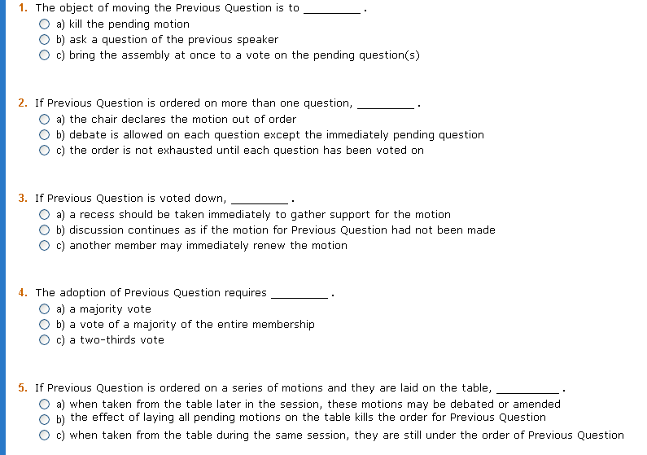
- C The object of moving the Previous Question is to bring the assembly at once to a vote on the pending question(s).
- C If Previous Question is ordered on more than one question, the order is not exhausted until each question has been voted on.
- B If Previous Question is voted down, discussion continues as if the motion for Previous Question had not been made.
- C The adoption of Previous Question requires a two-thirds vote.
- C If Previous Question is ordered on a series of motions and they are laid on the table, when taken from the table during the same session, they are still under the order of Previous Question.

Postpone to a Certain Time (Postpone Definitely)
Rod G Davidson, Professional Registered Parliamentarian www.parlipro.org
Puzzled by the motion to Postpone to a Certain Time (or Postpone Definitely)? After you complete this online module and take the short quiz to test your understanding and refresh your memory, you will feel more confident about this parliamentary puzzler. Here’s a chance to learn a thing or two about the motion to Postpone, courtesy of the public domain version of Robert's Rules of Order Revised, Fourth Edition.

The motion to Postpone to a Certain Time (or Postpone Definitely) allows for limited debate which must not go into the merits of the main question any more than is necessary to enable the assembly to determine the propriety of the postponement. It may be amended as to the time, and also by making the postponed question a special order. It cannot be laid on the table alone, but when it is pending the main question may be laid on the table which carries with it the motion to postpone. It cannot be committed or postponed indefinitely. It may be reconsidered. When it makes a question a special order it requires a two-thirds vote.

The time to which a question is postponed must fall within the session or the next session, and, if it is desired to postpone it to a different time, which must not be beyond the next regular session, it is necessary first to fix the time for an adjourned meeting, and then the question may be postponed to that meeting. Neither the motion to postpone definitely nor an amendment to it, is in order when it has the effect of an indefinite postponement; that is, to defeat the measure, as, for instance, to postpone until tomorrow a motion to accept an invitation to a banquet tonight. If the motion to postpone indefinitely is in order at the time, the chair may treat it as such at his discretion, but it cannot be recognized as a motion to postpone definitely.

It is not in order to postpone a class of business, as reports of committees; as each report is announced or called for, it may be postponed, or the rules may be suspended by a two-thirds vote and the desired question be taken up. A matter that is required by the by-laws to be attended to at a specified time or meeting as the election of officers cannot, in advance, be postponed to another time or meeting, but when that specified time or meeting arrives the assembly may postpone it to an adjourned meeting. When a question has been postponed to a certain time, it becomes an order of the day for that time and cannot be taken up before that time except by a reconsideration, or by suspending the rules for that purpose, which requires a two-thirds vote.

The Form of this motion depends upon the object sought.
(1) If the object is simply to postpone the question to the next meeting, the form of the motion is "to postpone the question [or, that the question be postponed] to the next meeting." It then becomes a General Order for that meeting, and handled under Unfinished Business and General Orders.
(2) If the object is to specify an hour when the question will be taken up as soon as the question then pending, if there is any, is disposed of, the form is similar to this: "I move that the question be postponed to 3 P.M."
(3) If it is desired to postpone the question until after a certain event, when it shall immediately come up, the form is, "To postpone the question until after the address on Economics."
(4) If the object is to insure its not being crowded out by other matters there should be added to the motion to postpone as given in the first two cases above, the words, "and be made a special order." Or the motion may be made thus: "I move that the question be postponed and made a special order for the next meeting [or, for 3 P.M. tomorrow]." The motion in this form requires a two-thirds vote, as it suspends the rules that may interfere with its consideration at the time specified as explained under Orders of the Day.
(5) If it is desired to postpone a question to an adjourned meeting and devote the entire time, if necessary, to its consideration, as in case of revising by-laws, after providing for the adjourned meeting the motion should be made in this form: "I move that the question be postponed and made the special order for next Tuesday evening." Or, a question may be postponed and made the special order for the next regular meeting.

The Effect of postponing a question is to make it an order of the day for the time to which it was postponed, and if it is not then disposed of, it becomes Unfinished Business. Postponing a question to a certain hour does not make it a special order unless so specified in the motion. The motion to postpone definitely may be amended by a majority vote so as to make the amended motion one to make the question a special order. If this is done the amended motion will require a two-thirds vote.

Now, test your understanding of the motion to Postpone to a Certain Time. Answer the questions below and then click the button underneath to see your results. Good luck!
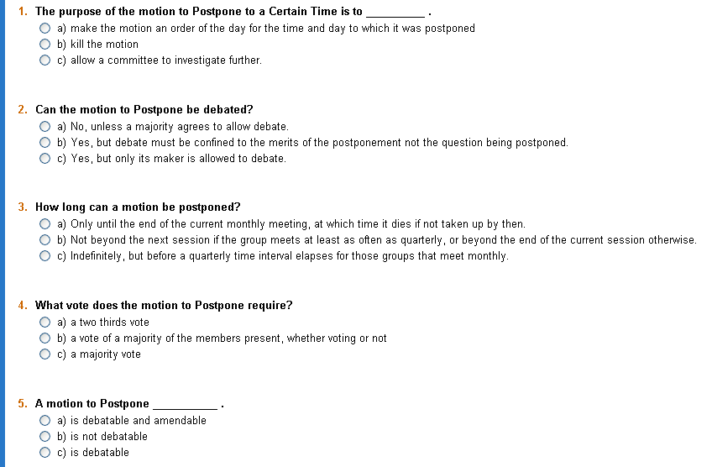
- A The purpose of the motion to Postpone to a Certain Time is to make the motion an order of the day for the time and day to which it was postponed.
- B The motion to Postpone can be debated, but debate must be confined to the merits of the postponement, not the question being postponed.
- B A motion cannot be postponed beyond the next session if the group meets at least as often as quarterly, or beyond the end of the current session otherwise.
- C The motion to Postpone requires a majority vote.
- A A motion to Postpone is debatable and amendable.

Postpone Indefinitely
Rod G Davidson, Professional Registered Parliamentarian www.parlipro.org
Puzzled by the motion to Postpone Indefinitely? After you complete this online module and take the short quiz to test your understanding and refresh your memory, you will feel more confident about this parliamentary puzzler. Here’s a chance to learn a thing or two about the motion to Postpone Indefinitely, courtesy of the public domain version of Robert's Rules of Order Revised, Fourth Edition.

The motion to Postpone Indefinitely takes precedence of nothing except the main motion to which it is applied, and yields to all privileged, incidental, and other subsidiary motions. It cannot be amended or have any other subsidiary motion applied to it except the previous question and motions limiting or extending the limits of debate. It is debatable and opens the main question to debate. It can be applied to nothing but main questions, which include questions of privilege and orders of the day after they are before the assembly for consideration. An affirmative vote on it may be reconsidered, but not a negative vote. If lost it cannot be renewed. It is simply a motion to reject the main question. If a main motion is referred to a committee while to postpone indefinitely is pending, the latter motion is ignored and does not go to the committee.

The Purpose of this motion is not to postpone, but to reject, the main motion without incurring the risk of a direct vote on it, and it is made only by the enemies of the main motion when they are in doubt as to their being in the majority.

The Effect of making this motion is to enable members who have exhausted their right of debate on the main question, to speak again, as technically, the question before the assembly is different, while, as far as the subject of discussion is concerned, there is no difference caused by changing the question from adopting to rejecting the measure, because the merits of the main question are open to debate in either case. If adopted, its effect is to suppress the main motion for that session, unless the vote is reconsidered.

As this motion does not suppress the debate on the main question, its only useful effect is to give the opponents of the pending measure a chance of killing the main motion without risking its adoption in case of failure. For, if they carry the indefinite postponement, the main question is suppressed for the session; if they fail, they still have a vote on the main question, and, having learned their strength by the vote taken, they can form an opinion of the advisability of continuing the struggle.

Now, test your understanding of the motion to Postpone Indefinitely. Answer the questions below and then click the button underneath to see your results. Good luck!
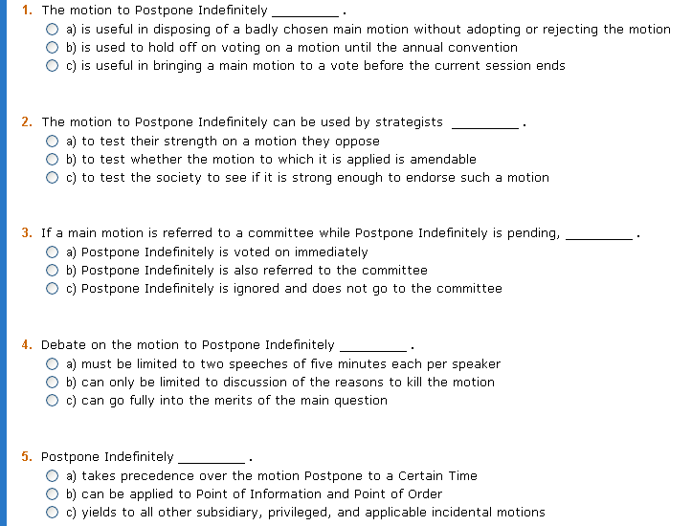
- A The motion to Postpone Indefinitely is useful in disposing of a badly chosen main motion without adopting or rejecting the motion.
- A The motion to Postpone Indefinitely can be used by strategists to test their strength on a motion they oppose.
- C If a main motion is referred to a committee while Postpone Indefinitely is pending, Postpone Indefinitely is ignored and does not go to the committee.
- C Debate on the motion to Postpone Indefinitely can go fully into the merits of the main question.
- C Postpone Indefinitely yields to all other subsidiary, privileged, and applicable incidental motions.

Take from the Table
Rod G Davidson, Professional Registered Parliamentarian www.parlipro.org
Puzzled by the motion to Take from the Table? After you complete this online module and take the short quiz to test your understanding and refresh your memory, you will feel more confident about this parliamentary puzzler. Here’s a chance to learn a thing or two about the motion to Take from the Table, courtesy of the public domain version of Robert's Rules of Order Revised, Fourth Edition.

The motion to Take from the Table has the right of way in preference to main motions if made during the session in which it was laid on the table while no question is actually pending, and at a time when business of this class, or unfinished business, or new business, is in order; and also during the next session in societies having regular business meetings as frequently as quarterly. It yields to privileged and incidental motions, but not to subsidiary ones. It is undebatable, and no subsidiary motion can be applied to it. It is not in order unless some business has been transacted since the question was laid on the table, nor can it be renewed until some business has been transacted since it was lost. The motion to take from the table cannot be reconsidered, as it can be renewed repeatedly if lost, and, if carried, the question can be again laid on the table after progress in debate or business.

In ordinary deliberative assemblies, a question is supposed to be laid on the table only temporarily with the expectation of its consideration being resumed after the disposal of the interrupting question, or at a more convenient time. As soon as the question that was introduced when the first question was laid on the table, is disposed of, any one may move to take this first question from the table. When he rises to make the motion, if the chair recognizes some one else as having first risen, he should at once say that he rises to move to take a question from the table. The chair then assigns him the floor if the other member has risen to make a main motion. If the new main motion has been stated by the chair before he claims the floor, he must wait until that question is disposed of before his motion will be in order.

When taken up, the question with everything adhering to it is before the assembly exactly as when it was laid on the table. Thus, if a resolution has amendments and a motion to commit pending at the time it was laid on the table, when it is taken from the table the question is first on the motion to commit. If a motion to postpone to a certain time is pending when the question is laid on the table, and it is taken from the table after that time, then the motion to postpone is ignored when the question is taken up.

If the question is taken up on the day it was laid on the table, members who have exhausted their right of debate cannot again speak on the question. But if taken up on another day, no notice is taken of speeches previously made. The previous question is not exhausted if the question upon which it was ordered is taken from the table at the same session, even though it is on another day.

Now, test your understanding of the motion to Take from the Table. Answer the questions below and then click the button underneath to see your results. Good luck!
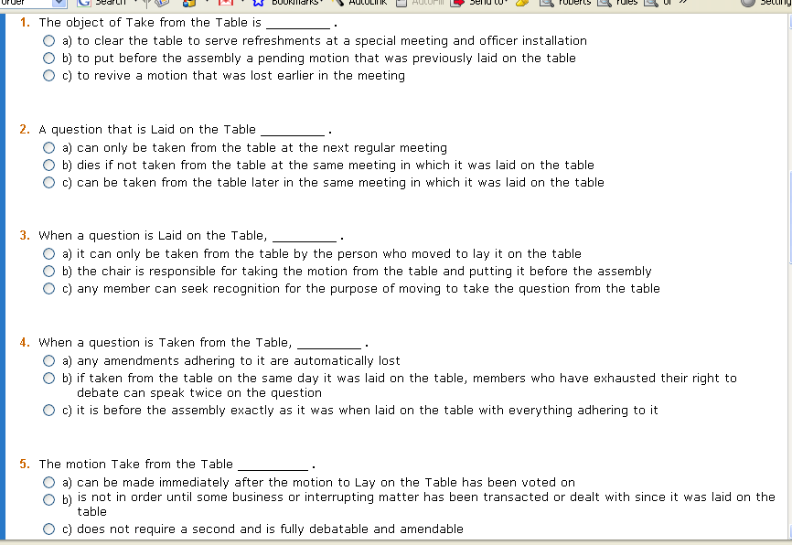
1. B The object of Take from the Table is to put before the assembly a pending motion that was previously laid on the table.
2. C A question that is Laid on the Table can be taken from the table later in the same meeting in which it was laid on the table.
3. C When a question is Laid on the Table, any member can seek recognition for the purpose of moving to take the question from the table.
4. C When a question is Taken from the Table, it is before the assembly exactly as it was when laid on the table with everything adhering to it.
5. B The motion Take from the Table is not in order until some business or interrupting matter has been transacted or dealt with since it was laid on the table.


Companion website to
Robert's Rules Online - www.RulesOnline.com
with full-text keyword search of the Fourth Edition of Robert's Rules

Puzzled by Parlipro? Tongue-tied by motions? Perplexed by whether a motion is debatable or amendable? Who came up with the rules of parliamentary procedure anyway? With our online tutorial, here's a chance to learn a thing or two about motions and parliamentary procedure, courtesy of the public domain version of Robert's Rules of Order Revised, Fourth Edition.
The Book of Rules for the rules we rule by!! www.RulesOnline.com was recently featured on Sound*Bytes Radio a national radio show distributed to the over 500 stations on the CBS News network. The show, hosted by Jan Ziff, is in its thirteenth year of continuous broadcast.

According to Robert's Rules of Order, parliamentary procedure is based on the consideration of the rights of the majority, the rights of the minority (especially a large minority greater than one-third), the rights of individual members, the rights of absentee members, and the rights of all of these groups taken together.

This website www.parlipro.org is dedicated to advancing the knowledge of parliamentary procedure, which can be fun, as well as educational. Some of the educational material on this website comes from Robert's Rules of Order Revised, Fourth Edition. This is an important book, mostly consistent with all later editions, and can be helpful in the study of parliamentary procedure; however, the most current edition of the work of Henry M. Robert is Robert's Rules of Order Newly Revised (RONR), 10th Edition © 2000, which is the truly definitive source of information about parliamentary procedure.

If the bylaws* of an organization specify RONR as the adopted parliamentary authority, then that book should be used. The Fourth edition can serve as a useful reference tool but, by all means, get a copy of the current edition of RONR; it contains much information and details not available in the Fourth Edition.

Simplified Roberts Rules of Order
Sonoma State University Academic Senate

Main ideas:
o Everyone has the right to speak once if they wish, before anyone may speak a second time.
o Everyone has the right to know what is going on at all times.
o Only urgent matters may interrupt a speaker.
o The [members] discuss only one thing at a time.

How to do things:
1. You want to bring up a new idea before the group.
After recognition by the [president], present your motion. A second is required for the motion to go to the floor for debate, or consideration.
2. You want a motion just introduced by another person to be killed.
Without recognition from the [president] simply state "I object to consideration." This must be done before any debate. This motion requires no second, is not debatable and requires a 2/3 vote.
3. You want to change some of the wording in a motion under debate.
After recognition by the [president], move to amend by
1. adding words,
2. striking words or
3. striking and inserting words.
4. You like the idea of a motion under debate, but you need to reword it beyond simple word changes.
Move to substitute your motion for the original motion. If it is seconded, debate will continue on both motions and eventually the body will vote on which motion they prefer.
5. You want more study and/or investigation given to the idea under debate.
Move to refer to a committee. Try to be specific as to the charge to the committee.
6. You want more time personally to study the proposal under debate.
Move to postpone to a definite time or date.
7. You are tired of the current debate.
Move to limit debate to a set period of time or to a set number of speakers. Requires a 2/3 vote.
8. You have heard enough debate.
Move to close the debate. Requires a 2/3 vote.
Or move to previous question. This cuts off debate and brings the assembly to a vote on the pending question only. Requires a 2/3 vote.
9. You want to postpone a motion until some later time.
Move to table the motion. The motion may be taken from the table after 1 item of business has been conducted. If the motion is not taken from the table by the end of the next meeting, it is dead. To kill a motion at the time it is tabled requires a 2/3 vote. A majority is required to table a motion without killing it.
10. You want to take a short break.
Move to recess for a set period of time.
11. You want to end the meeting.
Move to adjourn.
12. You are unsure that the [president]has announced the results of a vote correctly.
Without being recognized, call for a “division of the house." At this point a standing vote will be taken.
13. You are confused about a procedure being used and want clarification.
Without recognition, call for "Point of Information" or "Point of Parliamentary Inquiry." The [president] will ask you to state your question and will attempt to clarify the situation.
14. You have changed your mind about something that was voted on earlier in the meeting for which you were on the winning side.
Move to reconsider. If the majority agrees, the motion comes back on the floor as though the vote had not occurred.
15. You want to change an action voted on at an earlier meeting.
Move to rescind. If previous written notice is given, a simple majority is required. If no notice is given, as 2/3 vote is required.

You may INTERRUPT a speaker for these reasons only:
o to get information about business - point of information
o to get information about rules - parliamentary inquiry
o if you can't hear, safety reasons, comfort, etc. - question of privilege
o if you see a breach of the rules - point of order
o if you disagree with the [president]'s ruling - appeal

You may influence WHAT the [members] discuss:
o if you would like to discuss something - motion
o if you would like to change a motion under discussion - amend

You may influence HOW and WHEN the [members] discuss a motion:
o if you want to limit debate on something - limit debate
o if you want a committee to evaluate the topic and report back - commit
o if you want to discuss the topic at another time - postpone or lay it on the table
o if you think people are ready to vote - previous question

Parliamentary Procedure Motions Chart

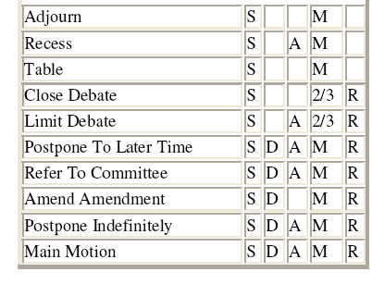•
S = Must Be Seconded
D = Debatable
A = Amendable
M = Requires A Simple Majority Vote
2/3 = Requires A 2/3 Vote
R = May Be Reconsidered or Rescinded

Adapted from Case Western Reserve Graduate Student Senate; changes in [ ]
http://www.cwru.edu/orgs/gradsenate/rules/handbook.html

Sonoma State University Academic Senate
Robert’s Rules of Order Made Simple
Rules for Common Motions at our Senate - download

Points
The following three points are always in order:
- Point of Order: .When a member thinks that the rules of the assembly are being violated, s/he can make a Point of Order (or "raise a question of order," as it is sometimes expressed), thereby calling upon the chair for a ruling and an enforcement of the regular rules.
- Point of Information: a request for information on a specific question, either about process or about the content of a motion. A point of information does not give the speaker the privilege to provide information. If you have information for the body, raise your hand to be put on the speakers list.
- Point of PersonalQuestion of Privilege: a comment addressing a personal need - a direct response to a comment defaming one's character, a plea to open the windows, etc.a device that permits a request or main motion relating to the rights and privileges of the assembly or any of its members to be brought up for possible immediate consideration because of its urgency, while business is pending and the request or motion would otherwise be out of order.The most common example is a motion to enter into Executive Session. Our Senate rarely does this.Questions of Personal Privilege are almost never ruled in order to interrupt business.
Motions
* All main motions must be seconded, and are adopted by a majority vote unless otherwise noted.
* All main motions may be debated unless otherwise noted.
Motions are of four or five types: privileged, subsidiary, incidental, main and motions that bring a question again before the assembly.
- Privileged motions have precedence over nearly all other motions. They fall within a list of precedence.
- Subsidiary motions yield precedence to the privileged motions and take precedence over main motions. They fall within a list of precedence.Subsidiary motions assist the assembly in treating or disposing of a main motion (and sometimesother motions).
- Incidental motions do not properly fall within the list of precedence, since they usually arise out of the business of the assembly. They may be proposed at any time, and must be decided as they arise. They fall within no list of precedence among themselves.
- Original main motions and incidental main motions differ principally in the nature of their subject matter. Original main motions bring business before the group, and incidental main motions is a main motion that is incidental to or relates to the business of the assembly, or its past or future action. bring a question again before the group. Those motions are of the lowest rank and take precedence over no others. They fall within no list of precedence among themselves.
- Motions that bring a question again before the assembly– Fall within no list of precedence among themselves. Like main motions, all of the motions that bring a question again before the assembly are usually made (and three of them can only be made) while no business is pending.

The following Motions are in order of precedence: motions may be made only if no motion of equal or higher precedence is on the floor (i.e., don't do a number 9 (refer to committee) when the body is considering a number 7 (motion to extend or limit debate).

1. Fix The Time to Which to Adjourn – Sets the time for an adjourned meetingwhich is a continuation of the current meeting held at another time before the next regular meeting.
2. Motion to Adjourn - not debatable; goes to immediate majority vote.
3. Motion to Recess - not debatable. May be for a specific time.
4. Call for Orders of the Day – A demand to return to the regular order of business.
5. Lay on the Table – Misused 99.999999% of the time. This motion is only used to set aside the pending motion to take up something more urgent, with the full expectation of returning to the motion. It is NOT intended to kill a motion and cannot be used for that purpose due to its high rank.
6. Move for the Previous Question; Motion to End Debate and Vote; Call the Question - A motion to close debate immediately and vote now on the pending motion. Applies only to the motion on the floor. Not debatable; requires 2/3 vote.
7. Motion to Limit or Extend Debate - can be general, or for a specific time or number of speakers. Not debatable.
8. Postpone to a Certain Time – Postpones the current motion to the next session or to an adjourned meeting.
9. Motion to Refer to Committee - applies only to the main motion. Refers question to a specific group with a specific time and charge.
10. Motion to Amend - must be voted for by a majority to be considered and to be passed.
11. Postpone Indefinitely – Kills the motion without directly voting it down
12. Main Motion - what it is you're debating and amending.

Motions can also be classified according to purpose or special situation:

To modify a motion:
Amend (Subsidiary)

To suppress debate or hasten action:
Call for orders of the day (Privileged)
Previous question (Subsidiary)
Limit debate (Subsidiary)
Suspend rules (Incidental)
Take from the table (Main) (Motions that bring a question again before the assembly)
Make special order of business (Main) (not a classified motion in and of itself. It is often tacked on to a motion to postpone, or during the adoption of an agenda)

To delay action:
Postpone to a definite time (Subsidiary) – The motion that almost always should be used instead of lay on the table.
To lay on the table (Subsidiary) – Almost Never in Order.
Refer to committee (Subsidiary)

To prevent action:
Postpone indefinitely (Subsidiary)
Object to consideration (Incidental)
Withdraw a motion (Incidental)

To consider more carefully:
Extend debate (Subsidiary)
Divide question (Incidental)
Committee of the whole (Incidental)
To change a decision: (Motions that Bring a Question again before the assembly)
Reconsider (Main)
Rescind or Amend Something Previously Adopted (Main)
To maintain rules and order:
Question of privilege (Privileged)
Point of order (Privileged)
Appeal from decision of chair (Incidental)
Parliamentary inquiry (Incidental)
Request for information (Incidental)
To close a meeting:
To fix time of next meeting (Privileged)
Adjourn (Privileged)
Recess (Privileged)

Glossary

Amend
An amendment is a motion to change, to add words to, or to omit words from, a pending n original motion. The change is usually to clarify or improve the wording of the original motion and must, of course, be germane to that motion.
An amendment cannot interrupt another speaker, must be seconded, is debatable if the motion to be amended is debatable, may itself be amended by an amendment to the amendment, can be reconsidered, and requires a majority vote, even if the motion to be amended requires a two-thirds vote to be adopted.
The chair should allow full discussion of the amendment (being careful to restrict debate to the amendment, not the original motion) and should then have a vote taken on the amendment only, making sure the members know they are voting on the amendment, but not on the original motion. The assembly can order the previous question on this motion the same as any debatable motion.
If the amendment is defeated, another amendment may be proposed, or discussion will proceed on the original motion.
If the amendment carries, the meeting does not necessarily vote immediately on the "motion as amended." Because the discussion of the principle of the original motion was not permitted during debate on the amendment, there may be members who want to speak now on the issue raised in the original motion.
Other amendments may also be proposed, provided that they do not alter or nullify the amendments already passed. Finally, the meeting will vote on the "motion as amended" or, if all amendments are defeated, on the original motion.
An amendment to an amendment is a motion to change, to add words to, or omit words from, the first amendment. The rules for an amendment (above) apply here, except that the amendment to an amendment is not itself amendable and that it takes precedence over the first amendment.
Debate proceeds and a vote is taken on the amendment to the amendment, then on the first amendment, and finally on the original motion ("as amended," if the amendment has been carried). Only one amendment to an amendment is permissible.
Sometimes a main motion is worded poorly, and several amendments may be presented to improve the wording. In such cases it is sometimes better to have a substitute motion rather than to try to solve the wording problem with amendments.
An individual (or a group of two or three) can be asked to prepare a substitute wording for the original motion. If there is unanimous agreement, the meeting can agree to the withdrawal of the original motion (together with any amendments passed or pending) and the substitution of the new motion for debate.

Point of Order
This motion permits a member to draw the chair's attention to what he/she believes to be an error in procedure or a lack of decorum in debate. The member will rise and say: "I rise to a point of order," or simply "Point of order." The chair should recognize the member, who will then state the point of order. The effect is to require the chair to make an immediate ruling on the question involved. The chair will usually give his/her reasons for making the ruling. If the ruling is thought to be wrong, the chair can be challenged. A point of order can interrupt another speaker, does not require a second, is not debatable, is not amendable, and cannot be reconsidered.

Requests and Inquiries
a. Parliamentary Inquiry. A request for the chair's opinion (not a ruling) on a matter of parliamentary procedure as it relates to the business at hand. This opinion is not subject to appeal.
b. Point of Information. A question about facts affecting the business at hand-directed to the chair. The chair then directs all questions “through the chair” to the member. A member should only address the chair.
c. Request for Permission to Withdraw or Modify a Motion. Although Robert's Rules of Order specify that until a motion has been accepted by the chair it is the property of the mover, who can withdraw it or modify it as s/he chooses, a common practice is that once the agenda has been adopted, the items on it become the property of the meeting. A person may not, therefore, withdraw a motion unilaterally; he or she may do so only with the consent of the meeting, which has adopted an agenda indicating that the motion is to be debated.

Similarly, a person cannot, without the consent of the meeting, change the wording of any motion that has been given ahead of time to those attending the meeting-for example, distributed in printed form in advance, printed on the agenda, a motion of which notice has been given at a previous meeting, etc. If a person does want to change the wording, they must move to substitute or amend before the body can consider the changed motion.
The usual way in which consent of a meeting to withdraw a motion is obtained is for the mover to ask the consent of the meeting to withdraw (or change the wording). If no one objects, the chairperson announces that there being no objections, that the motion is withdrawn or that the modified wording is the motion to be debated.
If anyone objects, the chair can put a motion permitting the member to withdraw (or modify) or any two members may move and second that permission be granted. A majority vote decides the question of modifying a motion--similar to amending the motion. A two-thirds majority is needed for permission to withdraw a motion, as this has the effect of amending the agenda.

Motions Related to Methods of Voting
A member can move that a vote be taken by roll call, by ballot or that the standing vote be counted if a division of the meeting appears to be inconclusive and the chair neglects to order a count. Such motions may not interrupt another speaker, must be seconded, are not debatable, are amendable, can be reconsidered, and require majority votes. By-laws may specify a secret ballot for such votes as the election of officers which is not suspendable under any circumstances.

Quorum of Members
Before a meeting can conduct business it requires a quorum--the minimum number of members who must be present at the meeting before business can be legally transacted. The requirement of a quorum is a protection against unrepresentative action in the name of the association by an unduly small number of people.

Postpone Indefinitely
Despite its name, this motion is not one to postpone, but one to suppress or kill a pending main motion.
If an embarrassing main motion is brought before a meeting, a member can propose to dispose of the question (without bringing it to a direct vote) by moving to postpone indefinitely. Such a motion can be made at any time nothing other when than the main motion is pending except when a speaker has the floor. If passed, the motion kills the matter under consideration. It requires a second, may be debated (including debate on the main motion), cannot be amended, can be reconsidered only if the motion is passed, and requires a majority vote.

Refer
When it is obvious that a meeting does not have enough information to make a wise decision, or when it seems advisable to have a small group work out details that would take too much time in a large meeting, a member may move: "That the question be referred to the ______ committee" (or "to a committee"--not named).

A motion to refer cannot interrupt another speaker, must be seconded, is debatable only as to the propriety or advisability of referral, can be amended, can be reconsidered if the group to which the question has been referred has not begun work on the matter, and requires a majority vote. If a motion to refer is passed, the committee to which the matter is referred should report on the question at a subsequent meeting. Sometimes the motion to refer will state the time at which a report will be required.

Table (Lay on the Table)
Sometimes a meeting wants to lay a main motion aside temporarily without setting a time for resuming its consideration but with the provision that the motion can be taken up again whenever the majority so decides. This is accomplished by a motion to table or to lay on the table. Tabling should only be used to take up something very urgent and then return to the tabled motion.

Adjourn
A member can propose to close the meeting entirely and immediately by moving to adjourn. This motion can be made and the meeting can adjourn even while business is pending, providing that the time for the next meeting is established by a rule of the association or has been set by the meeting. In such a case, unfinished business is carried over to the next meeting. A motion to adjourn may not interrupt another speaker, must be seconded, is not debatable, is not amendable, cannot be reconsidered, and requires a majority vote.

Recess
A member can propose a short intermission in a meeting, even while business is pending, by moving to recess for a specified length of time. A motion to take a recess may not interrupt another speaker, must be seconded, is not debatable, can be amended (for example, to change the length of the recess), cannot be reconsidered, and requires a majority vote.

Prepared by Laurel Holmström, Academic Senate Analyst Spring 2006
The Academic Senate is grateful to George Mervosh, Professional Registered Parliamentarian for his assistance with this document.

